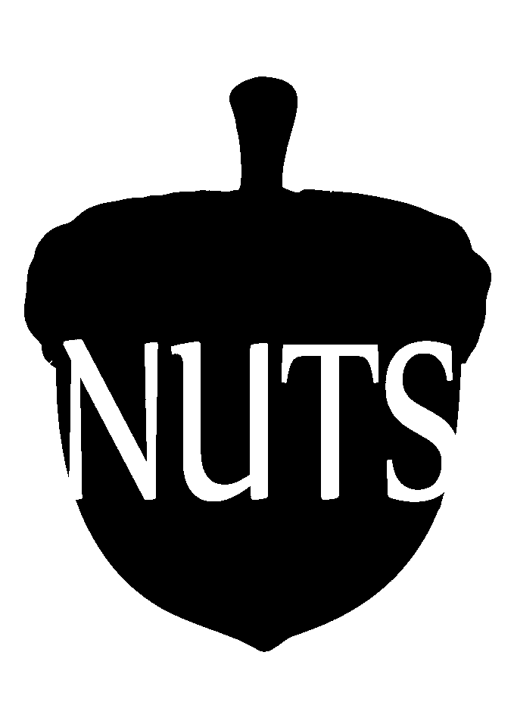

NUTS Poetry & Music Night 2024

All Performed Poetry
Simone de Vries

Sun-kissed Wings
Don’t fly too close to the sun, they say,
your wings of wax will melt
But they never once acknowledge
Just how joyful Icarus felt

His arms spread wide
Enjoying the scorching sun
That made his wax wings fail,
Yet never lessened his fun

Plunging back down to earth
He shouted out in glee
For while Icarus was failing
He finally was free

Elianne Kiers

After Dark
The city with its pretty lights is less delightful, after
I am told goodbye just one corner too early.
But, then again, my company, could not have known the fate awaiting
me beyond, below the lanterns, where the dark does dim the frightened
beating of the woman heart.

A flock of shadowy shapes of nightlife,
wildlife, whispering, whistling beaks; male songbirds don’t exist out here,
just soundless birds of prey and eat.
The alcoholic traces chasing me are yet to turn to
tracks too stale to smell; the heads will turn and tell

I am no hawk.
And yet I’ll walk as though I am, glide past the gaze, glide past the

black hoods,
unaware of unspoken fact, that they can afford eye-contact
unaware of quiet fear, that I may never again tread here
unaware of languageless words, feathered fauna, silent songbird’s
alien mantra: I am not dying tonight.

“Would you please walk me home?
Around the corner, I did park.”
“...”
“Why, the city with its pretty lights is less delightful, after
dark.”
Inis Andringa

the news
How I wish I didn’t know
everything. But we see it all
I wake up, check my phone and behold
all that is wrong in the world
today. And tomorrow, and on and on
sitting awake in my bed until dawn
thinking how did we get here
and how do we get out
I stop in the middle of the minefield
lamenting how I can’t get us out

Anders Hervik

Snow
The park is wrapped in a white blanket

People always miss it

Well, at least until it arrives

Then they complain

It’s too cold! It’s too slippery! It’s too much salt on the roads! Too
little! This Greta shit ain’t even real!

So, what do I think?

Well, I do like it now

Feels like I am in a movie

But my bet is that you sooner or later will find the movie under the
category “horror”

Thriller at best

Because I do wonder

Will my grandchildren ever experience this?

The beauty? The complaints? The debates on TV on whether or not
climate change is real?

Or will they simply refer to it as something from Medellin that you
put up your greedy ass nose to make the show go on for another 30
minutes?

Or something from an old Disney movie they watch in history class
about some princess with no shoe?

Shit, I don’t know

But let’s cheer on the boys in Dubai

Give the Sheikhs and the Billionaires our warmest regards

But to be honest,

I think we’ll all drown in boiling water

And maybe that’s the best outcome for everyone

Well,

At least for whomever selling floating freezers that run on solar

Carolien de Vaan

I Don’t Write Poems
I don't write poems
Poems are meant to be read
I write ramblings, stammerings, bumblings
Forever unfinished, untold, forgotten instead

Not written to make sense
or invoke feelings in anyone but me
Not able to withstand analysis or reason
or to be taken seriously

No deep hidden meaning
nor written with prosaic intent
An accident, mistake, slip of thumb
impossible to suppress or prevent

And when you look beneath the surface
you'll see my deception clear as day
a nickel-tongued pseudo-poet
grasping to put their pain on display

Inge Leugs

Follow
Is it darkness or light
A burden or
Freedom?
It’s unescapable
Inevitable
It gets misused and abused
A form of sin
Hidden behind nice words
And smiles

It’s in the corner of your eye
A shadow in the mind
Is it good
Or evil
Crooked and wicked
Poison
Or potential and victory?

How come
Power is so much like death?
Rosa Winterdijk

Not love
On my way home:

Seagulls fighting over a stale fry
(It’s a treat for their seagull spouse)

A shoplifter sliding shoes
(The ones his sister’s always wanted)

A couple bickering bitterly
(“You’re the cutest”, “no you are”)

When I feel loved,
Everything is love,
I can’t help it
Eden Krikke

Apology in the Morning After an Encounter with Death
saw him in the wild i
swear
to god
it was him
leaving starbucks with a skim milk latte
didn't mean to say it all accusing-like
but i said hey man
you're that guy
right
so he gave me a wish
honestly i didn't know it worked like that and
looking back
i guess i don’t know what i thought would
happen
but
i know world peace is pretty high on
your list and i know you want your brother back
from the dead pretty bad lately
or maybe i should have asked him to make sure
we'd stay together forever even though
i don't think i necessarily believe in that stuff
any more than i believe in praying
or making the bed every day
so forgive me
whatever came over me isn't a thing i
recognize when i’m sober
but when he hugged me
his breath was only a little worse than
i'd imagined
if my imagination counts for anything
and i got a good close look at a beetle
sort of twitching almost dead stuck on
the fabric on his shoulder
and his fingernails were all sort of grey and
deadly
in the way a rusty nail is deadly or a flat tire is
deadly
and the whole time he held me i
thought how i've never been held by someone
more gruesome than me before
thought how it was nice
forgive me darling
i'll ask for world peace next time
i'll keep my head on
afterwards we watched a cat cross four lanes
of traffic in one go
unscathed
and unbothered
and god help me i couldn’t stop laughing

Sam Silas Elzinga

A meeting with fate
back when we met
you flicked a match
and told me to come along
pulled me through fields,
and cosy cafés
in countries with strange names
introduced me
to your friends and
your strange acquaintances
somehow i fit
into your life
a mould carved for me in
stone, becoming
a new person
leaving the past behind
while letting you
take every beat
every breath, every thought
fate waited for us
patiently, and
because fate has the time
it has sat there
comfortably
smoking a cigarette
staring out of
the window into
our minds, into our lives
our hopes and dreams
and once it had
its eyes fixed on the prize
it wouldn’t let go
like the bad dog
that had sunk its teeth into
your favourite
teddy bear when
you were so tiny and small

unrepairable child
that’s what fate does best
the universe’s black sheep
but it carries
that title proud
without any shame or fear
it had the answer
key to the test
i didn’t know i was taking
i became anew
although you had
already made a deal
so
on a warm summer night
two candles swallow the
last bit of oxygen
surrounding them and they
start flickering before
eternally dying.

Dora Tatalovic

faust yearns, and i bleed
she is pedantic in her study of their composition:
aching to cut away at the fabric of their psyche
rip out the stitches of their genius
and sew it into her own skin
she is gluttonous and starving
her hunger for greatness rears its cannibalistic head
more
and more
and more,
it is not enough
she overindulges in their brilliance
she is sick to death
and somehow never quite sated,
nor entirely sane
there is no remedy
perfection lives and it breathes
and it festers inside of her
in the shape of a vitriolic parasite that snaps its jaws in her stomach
and black mould spread thickly across the confines of her mind:
marmalade made from the most rotten parts of herself
boiled and sickly sweet
the mutters hidden behind columns of consciousness turn towards crescendo
give yourself forward, fully
absolve circadian mediocrity
such inconsequential sacrifice
somewhere, she is acutely aware of this divine injustice:
how they are created as God’s gift
and she must become the Devil’s pawn
the flames of indulgence lick at her feet
for a moment the heat feels delicious
she pretends not to notice the sulphurous reek,
reaching out towards salvation
her features softened to that of a lover’s gaze
if being cleansed of mundanity is a sin
then let her be Sinner
let her be the cautionary tale
whispered from ear to ear
in the dead of night
the girl willingly consumed

she is unclean
but she is great
that is all that matters anyway.

Maureen Prins

Venus Flytrap
I hold the weight of the world on my chest
Yet my jeans have no pockets to equally distribute it
Sodom in my left one, Gomorrah in the right.
My wardrobe consists of a single sundress
For easy access, as they say
The key to my heart apparently locked away behind the crucifix drawn on my cervix
I’ll eat 6 kilograms of lipstick in my life just to make your lips want to touch mine
But they’ll spit fire when you find out I’m not like your mother
It took nineteen years for me to learn about the concept of performativity
Makes sense though, a frog doesn’t jump out of the pot when you boil it slowly
God forbid we start teaching the animals about science, isn’t one enough?
You buy me a drink and tell me you had a revelation last night
I hold myself back to tell you I had the same one in kindergarten
And I don’t blame you because you’ve never had to wear 6 kilograms of lipstick to make my lips
want to touch yours
All you had to do was wear a tight black shirt and act like my dad a little bit.
I never know what I’m saying but I always have too much to say
We live of off magic and maybes
Bleed in sworn secrecy
Scream as loud as we can
Internally, of course.
And wake up the next day to put on 6 kilograms of lipstick just to make your lips want to touch
mine.

My Hands Haunt Me
The sterling silver of the moon follows me into the dawn
A red mark pressed into my left ring finger
And I can only imagine you woke up like this, too
Except for the fact that your fingers were much shorter than mine
You were always jealous of my hands, you said
Piano fingers, my father told me.
I haven't touched a key since.
My mother's face, my aunts smile, my fathers hands, hair colour fabricated from chemicals in a
bottle
Maybe the manual can tell me who I am
Step 1. Remove the cap of bottle A (and tell him you're sorry again)
Step 2. Add bottle A to bottle B (and take down the photo of him holding you as a baby from
your wall)
Step 3. Shake thoroughly (and suck it up when he doesn't text you on your birthday)
Step 4. Evenly distribute over the hair (get a few more tattoos in the hope he doesn't recognise
you anymore)
Step 5. Don't recognise yourself anymore.
Step 6. Let sit for 20 minutes (kiss the ring on your left ring finger and wish she was here)
Step 7. Rinse until water runs clear (and something about water being thicker than blood)
Step 8. Remove any stains from hands or clothing immediately (but secretly hope your fingers
remain red forever so they look a little less like his)
Step 9. Touchup roots every 2 months (or whenever you start looking too much like your aunt
again)
And finally, Step 10. Leave in conditioner.
I always skip step 10, I don't like to let things linger
I never take that ring off my left finger
Except for when the manual tells me to
Something too precious to be tainted
But I guess you could say the same about my dignity
My hands haunt me. My fathers shape, my aunts rings, the stains from the same hairdye my
mother uses. Something about water being thicker than blood.
Something about hydrogen peroxide
Something about sterling silver rings
Something about piano fingers.
Something about I love you
My hands haunt me
And I haven't been able to remove the stains from the nailbeds she was so jealous of.

Lidya Sihombing

“Have you seen the girl who wears a rainbow at a funeral?”
The gossip, indeed, stays adamant
Everyone favours condemning bad judgment
There was no more need for any Adderall
“Have you seen those two who turn from the church?”
Far away, they all stay, catering for the arch
Eugoligzing in mass silence, indulging in the splurge
Escaping from the sinner's fate, by and large
“Have you decided to leave too, like all those going?”
The plea was tiny, almost inaudible
She was munching on all the things inedible
For once, she wished the world would stop growing
“Have you gone too far, like Icarus once was?”
Like always, it was one against the mass
All the butchers, butlers, and even candlemakers touched the grass
‘Why wouldn’t life be like glass?’
“Have you considered stopping?”
To that, they all stared, gawking
‘I don’t suppose you understand what all of this means?’
That one person was trapped between
For one day, she was found under the bridge
With her rainbow dress one more time
Anti-Christian emblem cemented in her dime
She was smiling ear-to-ear
She was finally free

Bastiaan van Engelen

Icarus is drowning in the background
For help he does not call or scream
He thinks there is no one around
Who can realise his failing dream
Once ascending to the brightest star
Rising to greater heights than before
Now having pushed his limits too far
Falling slowly to the ocean floor
Underwater his vision fades
Paralysed by his distress
Still in the water he waits
To be dragged out of his mess
Knowing, deep down inside the sea
“The only one who can get me out is me.”

Stenanos Vavakos

A spark to wake up to
We always notice sparks in the dark,
Or a bird flying in the bright blue sky;
Just like when passing by a mirror,
Our attention directs itself on that subject.

And as we go on with our daily lives,
Cycling, walking, talking and mind-wandering,
We look back and forget the paths we had chosen,
Getting from A to B, like a mechanism,
Seeing but not even noticing.

As we hear, but do not listen,
There comes the spark in the dark of our vision,
A detail waking us up, opening our eyelids,
And noticing the world as if for the first time again.

A mere spark in the daily darkness of our lives,
Whether sunny, cloudy, rainy, or perhaps warm,
Once the light allows the awareness of a fresh breath,
The sun slowly bestows upon your skin its soothing kisses.

Just like the sudden awareness of mechanically breathing,
Realising the effort in each foot while cycling,
Or smiling at the idea of controlling your eye-blinking,
That spark allows for a short break within our auto-pilot.

Thus taking a slower pace and noticing buildings and flowers,
While walking, seeing the ducks in a pond and cats stretching,
Sipping on your tea while parents teach their children cycling,
And at last, seeing- No. Noticing yourself in the mirror, shining.

For we go days, weeks, months and years, just existing,
When suddenly a spark ignites, when we should be living;
Slight rain while the sun out and smiling at its congruence,
For nature is the way it is and we decide our perception on it.

And like the high piano tile’s note waking you up during a concert,
So shall the spark, the bird, your friends or perhaps this poem be,
Elements that allow you, within your cycles, to wake up and step back,
Ultimately noticing the bigger picture.

Julius Kester

You might not like it
You might not like it
We’ve always been around
You might not like it
We have history as proof
You might not like it
We are Roman emperors and American senators
You might not like it
We will always be around
You might not like it
We exist

Esmée Odijk

(Black Noise)
I want to shout. SHOUT!
But when I open my mouth,
Nothing comes out.
Trapped in a box,
Can't find my way out.
My mind goes in circles,
Round and round.
I'm screaming at walls,
But don't hear a sound.

My limbs feel numb,
My mind goes blank,
My eyes turn black,
My heart's like a drum.
I fall down.
I hit the ground.
No exit found.
I can't go back,
To where I came from.

Then I hear,
A whisper clear.
A sweet sound,
That I hold dear.
I reach my hand,
And understand:
I'm not alone.
I'm not ungrand.
And my heart is not of stone.

Dimitriy Yaroshchuk

Tongue-Tilling
The tongue your parents had I only touched a single time
in a village with a sole telephone pole
Cracking, while your uncle showed me where we hid during the war and after and even now.
The cows with crooked horns – is that why they call the city Кривой Рог?
Or Кривий Рiг, rather, but I can’t even pronounce that the way your parents did.
An army of them.
The bells, the cows, the cracking graves.
Do you still cross yourself, every time you pass them?
Do you still tear the weeds from between the marble, sweating and tugging all day long?
I didn’t see the change you promised me you’d brought.
I was too young to help you out, you said.

I touched the marble crushing my father’s father after death that day, a tongue of stone. The earth dry and cracking. Something about to break.

Clíona Stafford

Orange Day
Red was the colour of my childhood.
Not shiny pink and plastic blue like the kids have today.
In this stifling July heat, orange is the colour that prevails.
The soldiers look different as they parade around the street.
They have swapped their camouflage for peacock feathers.
They have exchanged their guns for drums.

Bloodied, bruised, and battered my brother was when we found him,
Clutching onto a crimson splattered tricolour, like a lifeline.
As if his fervour would save him.
The walls of Derry are standing still, and despite it all so are we.
I watch the orange-clad greying men sauntering through the streets we are obliged to share.
I cannot help but remember Pearse’s words:
Ireland unfree will never be at peace.

